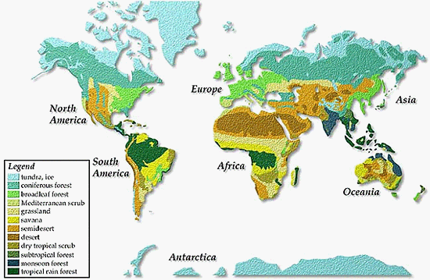

Activity 1: fill in table, make sure I can tell your answers (bold, or diff. color)
Climate Regions Summary Table: Observations from the Climate Map, above.
Northern Latitude
Color | Climate Region from Key | Orientation
 | Tundra | East West(E/W),  far North
Light Green
Bright Green | Broadleaf Forest
Light Brown | Grassland (Steppe) | E/W
Brown
 | Desert
Yellow |  | E/W Africa to  South America
 | Tropical Rain Forest

Activity 2, also from map, first page
- Where do the patterns for climate regions closely follow latitude?
- Where is the east west pattern of climate regions interrupted?
- In general, if you were to leave the equator and travel to either the north or south poles, what changes would you observe in temperature?
- What prediction would you make about the amount of precipitation a climate region receives based on its name?
- Why aren't climate regions nice and neat and exact?
http://www.earthonlinemedia.com/ipg/interactive_climate_map/climate_map.html
Using the interactive climate map, select three different sites, one near the equator, one mid-latitude, and one in high latitudes, and find the appropriate data for the following table
Global Climate Assessment Chart
Place | Latitude  (high, middle, low) | July Temperature  (hot, warm,  cool, cold) | January Temperature  (hot, warm,  cool, cold) | Annual Precipitation  (wet, dry,  wet/dry seasons)

Koppen Climate Classification
The Koppen Climate Classification System is the most widely used system for classifying the world's climates. Its categories are based on the annual and monthly averages of temperature and precipitation. The Koppen system recognizes five major climatic types; each type is designated by a capital letter.
A - Tropical Moist Climates: all months have average temperatures above 18° Celsius.
B - Dry Climates: with deficient precipitation during most of the year.
C - Moist Mid-latitude Climates: with Mild Winters.
D - Moist Mid-Latitude Climates: with Cold Winters.
E - Polar Climates: with extremely cold winters and summers.
You will be part of a group effort: each group will be assigned one of these climate types; your goal is to research this climate, geographically, and generate a presentation travel brochure on why everyone should plan a visit to this area of the world this summer. Make sure that you include the following points:
- The kind of vegetation they will see
- The wildlife they will see
- The kinds of houses they will see
- The kind of food that might be available
- The kind of recreation they might find
Useful resources, in addition to those already used here:
http://www.physicalgeography.net/fundamentals/7v.html
https://www.britannica.com/science/Koppen-climate-classification

